Experiment No .3

Network Connectivity Testing Tools

Gayatri A. Gomewadikar

PRN – 2010044

1.ipconfig

Windows command line utility that is used to manage the IP address assigned to the machine it is running in

It gives information about IPversion 6 address

subnet mask ,

default gateway

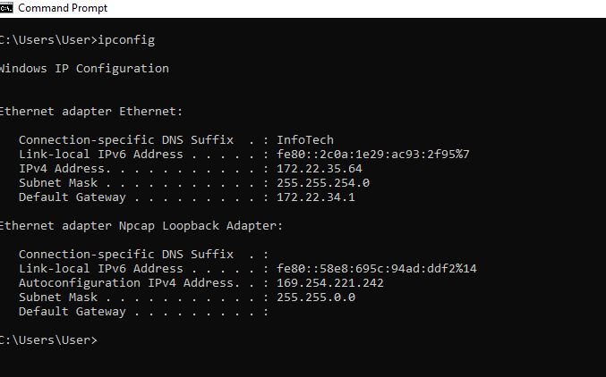

2.ipconfig/all

Displays the full TCP/IP configuration for all adapters.

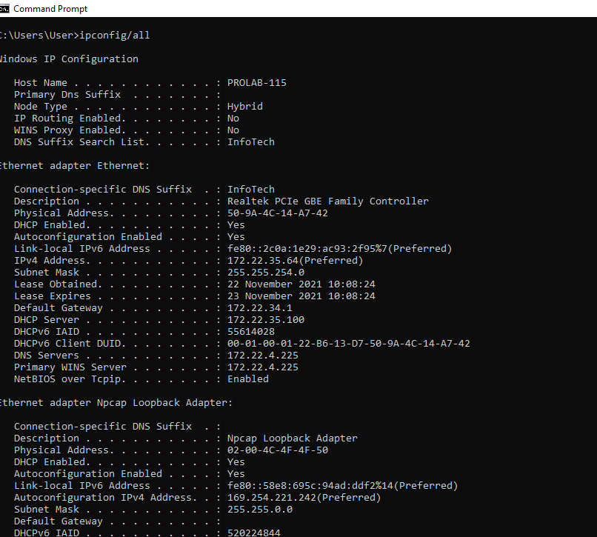

3.ping

[Ping](https://www.paessler.com/ping-monitoring) is a command-line utility, available on v operating system with network

connectivity, that acts as a **test to see if a networked device is reachable.**

ping ritindia.edu

The ping command sends out an *echo request*. If it finds the target system, the remote host sends back an *echo reply*.

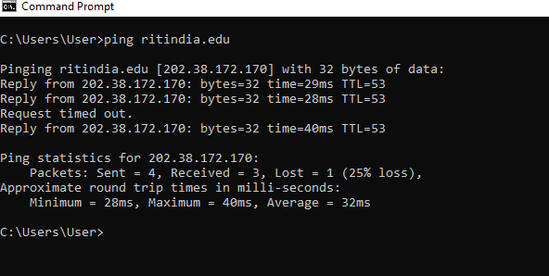

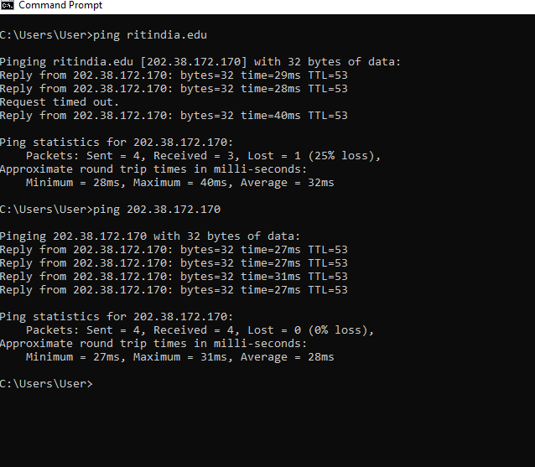

4.arp

arp command allows you to display and modify the Address Resolution Protocol (ARP) cache. An *ARP cache* is a simple mapping of IP addresses to MAC addresses

arp -a

To display the ARP cache entry for a specific IP address, use an -a switch followed by the IP address.

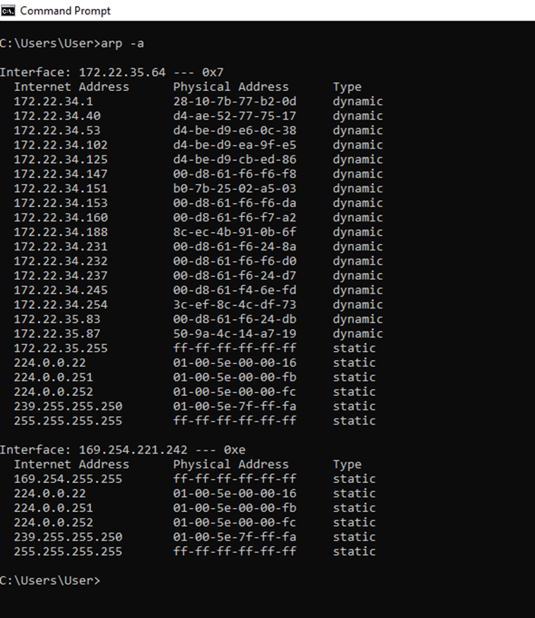

5.route print

To display the routing table (both IPv4 and IPv6) in Windows,we use the route print command

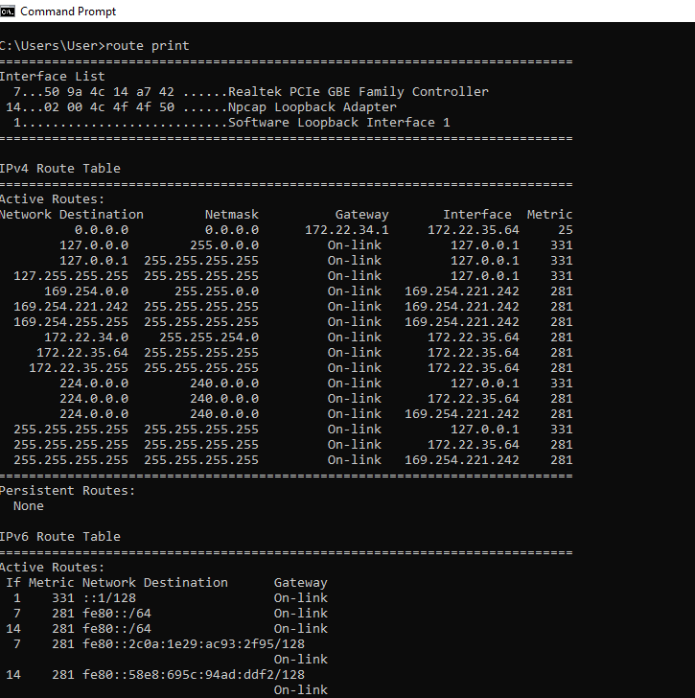

6.tracert

*Traceroute* is a command which can show you the path a packet of information takes from your computer to one you specify

tracert ritindia.edu

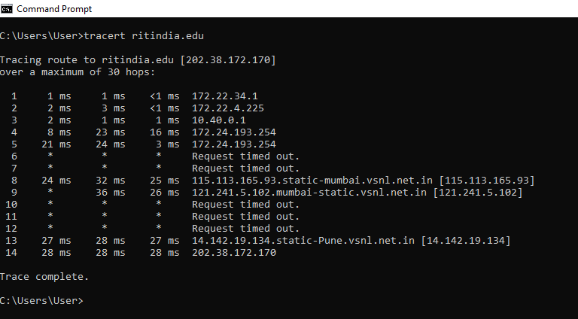

It will list all the routers it passes through until it reaches its destination, or fails to and is discarded. In addition to this, it will tell you how long each 'hop' from router to router takes

7.netstat

**netstat** (**net**work **stat**istics) is a [command-line](https://en.wikipedia.org/wiki/Command-line_interface) [network utility](https://en.wikipedia.org/wiki/Network_utility) that displays network connections for [Transmission Control Protocol](https://en.wikipedia.org/wiki/Transmission_Control_Protocol) (both incoming and outgoing), [routing tables](https://en.wikipedia.org/wiki/Routing_table), and a number of network interface ([network interface controller](https://en.wikipedia.org/wiki/Network_interface_controller) or [software-defined network interface](https://en.wikipedia.org/wiki/Virtual_Interface)) and network protocol statistics.

netstat -e

Shows statistics about your network connection (received and sent data packets, etc.)

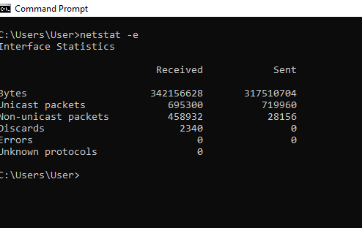

netstat -s -p icmp

netstat -p TCP function Displays the connections for the specified protocol, in this case TCP (also possible: UDP, TCPv6, or UDPv6)

